1. **INTRODUCTION**

In an online examination system examine get their user id and password with his/her admit card. This id is already saved in the examination server. When examine login to the server he/she get his/her profile already register. On the certain time examine gets the message to start the examination. All answers given by examine are saved into the server with his/her profile information. Online examination system also allows to correct the answer if the examine needed to change any answer in the examination time duration, however, after the time duration any change will not allow. This also makes checking the answer easy and error proof as computers are more accurate than man and provide fast results too. Php is a web base language so we can create an online examination system in PHP.

Online examinations are conducted through the internet or in an intranet (if within the Organization) to test a remote candidate .

Candidate is given a limited time to answer the questions and after the time expiry the answer paper is disabled automatically and answers is sent to the examiner

* 1. **Project Description**

Today Online MCQ Test becomes a fast growing examination method because of its speed and accuracy. It is also needed less manpower to execute the examination. Almost all organizations now-a-days, are conducting their objective exams by online examination system, it saves students time in examinations. Organizations can also easily check the performance of the student that they give in an examination. As a result of this, organizations are releasing results in less time. It also helps the environment by saving papers.

According to today’s requirement, online mcq test in php  is very useful to learn it.

**2. REQUIREMENT ANALYSIS:**

The problem here is to develop a web application which completely automize the examination process for an university.

To perform this the complete problem has been divided into five sub-problems so that they can be solved easily and after that can be integrated to make it an integrated working application

Online Registration / Enrollment of Student

* Online Login
* Online Schedule
* Online Manage the question bank
* Online Examination
* Online Result declaration
* Online  display randomly question.
* The questions will be display randomly from question bank.

At the Login module user name and password facility and  credentials should be checked properly at the time of login for student, expert, controller and Exam Dept. Admin.

In the schedule Module send  the exam schedule to the student.

In question bank module for the examination could be changed dynamically. Automatic checking of objective answers and manual checking of descriptive answers should be facilitated, if any. In the Objective answers module will be checked automatically by the system from the database and the subjective answer manually checking by exam department will take place.

In the exam module When the student  starts the exam the timer will start automatically and show the student how much time is left.

At result module display the result of each student and send by the exam. Dept.

**3. HARDWARE AND SOFTWARE SPECIFICATION**

**3.1 Hardware Requirement :**

Processor : Intel/AMD

RAM : 2GB RAM

HDD : 50 GB

**3.2 Software Requirement :**

Browser : Google Chrome

OS : Windows 10

Tools : Brackets(code editor)

Technologies : HTML, Java script, CSS, PHP, MySQL

Server : XAMPP Server to host the web-page.

**4. ANALYSIS AND DESIGN**

**4.1 MODULES AND THEIR DESCRIPTIONS:**

**Pages:**

➢ Home

➢ Register

➢ Login

➢ Logout

➢ view subjects

➢ Main page(where the user can take test)

➢take test

➢result

➢ Contact us

➢ About

**Home:**

The home page consist of the login and register modules. In this web application the first module is home page.

**Register:**

The user has to provide all the information to get registered in to the web application.

**Login:**

Once the user get registered in to the web application, then the user has to provide user name and password to get access into his account.

**Logout:**

The user can signoff/logout from his account.

**Main page:**

Main page consist of text editor, where the user can view subjects and also can take test.

**View subjects:**

The user can view all the available subjects before taking test.

**Take test**

The user can take test by selecting the particular subjest.

**Contact us:**

If the user want to contact us, they need to provide his own details .

**About:**

It contains the information about the web application and developers.

**4.2 SYSTEM PERSPECTIVE DESIGN**

**Online examination**

**Home** page

**Login**

**Register**

**Main**

**Contact us**

**About**

**view**

**Profile**

**4.3 Context Diagram:**

Admin

Student

Login register and

Add subject’s login test for quiz

Add test & subjects

Add questions topics

Sign-out

Results

Get marks get percentage with graph sheet

**4.5 E-R Diagram:**

Student

Admin

managees

Exam

appears

Admin home page

results

User home page

has

Sign-out

marks

Answers

**5. IMPLEMENTATION**

**5.1 Source code:**

**Main page:**

<html>

<head>

<title>Manin BS</title>

<meta name="viewport" content="width=device-width, initial-scale=1, user-scalable=no">

<link rel="stylesheet" type="text/css" href="1.page.css">

<link rel="stylesheet" href="https://use.fontawesome.com/releases/v5.4.1/css/all.css">

<style>

@import url('https://fonts.googleapis.com/css?family=Raleway');

body{

font-family: 'Raleway', sans-serif;

background-image:url("images/g.jpg");

background-size: cover;

background-repeat: no-repeat;

height: 100vh;

overflow: hidden;

display: flex;

justify-content: center;

align-items: center;

}

.all{

display: flex;

perspective: 10px;

transform: perspective(300px) rotateX(20deg);

will-change:perspective;

perspective-origin: center center;

transition: all 1.3s ease-out;

justify-content: center;

transform-style: preserve-3d;

}

.all:hover{

perspective: 1000px;

transition: all 1.3s ease-in;

transform: perspective(10000px) rotateX(0deg);

}

.all:hover .text{

opacity: 1;

}

.all:hover > div{

opacity: 1;

transition-delay: 0s;

}

.all:hover .explainer{

opacity: 0;

}

.left , .center, .right, .lefter, .righter{

width: 200px;

height: 150px;

transform-style: preserve-3d;

border-radius: 10px;

border:1px solid #fff;

box-shadow: 0 0 20px 5px rgba(100,100,255,.4);

opacity: 0;

transition: all .3s ease;

transition-delay: 1s;

position: relative;

background-position: center center;

background-size: contain;

background-repeat: no-repeat;

background-color: #58d;

cursor: pointer;

background-blend-mode: color-burn;

}

.left:hover, .center:hover, .right:hover, .lefter:hover, .righter:hover{

box-shadow: 0 0 30px 10px rgba(100,100,255,0.6);

background-color:#ccf;

}

.text{

transform: translateY(30px);

opacity: 0;

transition: all .3s ease;

bottom: 0;

left: 5px;

position: absolute;

will-change: transform;

color: #fff;

text-shadow: 0 0 5px rgba(100,100,255,.6);

}

.lefter{

transform: translateX(-60px) translateZ(-50px) rotateY(-10deg);

background-image: url(https://cdn3.iconfinder.com/data/icons/other-icons/48/organization-512.png);

}

.left{

transform: translateX(-30px) translateZ(-25px) rotateY(-5deg);

background-image: url(https://cdn3.iconfinder.com/data/icons/other-icons/48/creative_draw-512.png);

}

.center{

opacity: 1;

background-image: url(https://cdn3.iconfinder.com/data/icons/other-icons/48/app_window-512.png);

}

.right{

transform: translateX(30px) translateZ(-25px) rotateY(5deg);

background-image: url(https://cdn3.iconfinder.com/data/icons/other-icons/48/cloud_weather-512.png);

}

.righter{

transform: translateX(60px) translateZ(-50px) rotateY(10deg);

background-image: url(https://cdn3.iconfinder.com/data/icons/other-icons/48/search-512.png);

}

.explainer{

font-weight: 300;

font-size: 2rem;

color: #fff;

transition: all .6s ease;

width: 100%;

height: 100%;

background-color: #303050;

background-image: radial-gradient(circle at center top, #cce, #33a);

border-radius: 10px;

text-shadow: 0 0 10px rgba(255,255,255,.8);

display: flex;

justify-content: center;

align-items: center;

}

</style>

</head>

<body>

<div class="all">

<div class="lefter"><a href="about.php">

<div class="text">Admin Details</div></a>

</div>

<div class="center"><a href="index.php">

<div class="explainer"><span>Brain Sizzlers</span></div>

<div class="text">Student Login</div></a>

</div>

<div class="right"><a href="contact/contact.html">

<div class="text">Contact</div></a>

</div>

</div>

</body>

</html>

Index page:

<?php

session_start();

?>

<html>

<head>

<title>brain sizzling</title>

<meta charset="UTF-8">

<meta name="viewport" content="width=device-width, initial-scale=1">

<!--===============================================================================================-->

<link rel="icon" type="image/png" href="images/icons/favicon.ico"/>

<!--===============================================================================================-->

<link rel="stylesheet" type="text/css" href="vendor/bootstrap/css/bootstrap.min.css">

<!--===============================================================================================-->

<link rel="stylesheet" type="text/css" href="fonts/font-awesome-4.7.0/css/font-awesome.min.css">

<!--===============================================================================================-->

<link rel="stylesheet" type="text/css" href="vendor/animate/animate.css">

<!--===============================================================================================-->

<link rel="stylesheet" type="text/css" href="vendor/css-hamburgers/hamburgers.min.css">

<!--===============================================================================================-->

<link rel="stylesheet" type="text/css" href="vendor/select2/select2.min.css">

<!--===============================================================================================-->

<link rel="stylesheet" type="text/css" href="css/util.css">

<link rel="stylesheet" type="text/css" href="css/main.css">

<!--===============================================================================================-->

<style>

body

.glow {

font-size: 20px;

color: green;

text-align: center;

-webkit-animation: glow 1s ease-in-out infinite alternate;

-moz-animation: glow 1s ease-in-out infinite alternate;

animation: glow 1s ease-in-out infinite alternate;

}

@-webkit-keyframes glow {

from {

text-shadow: 0 0 1px #fff, 0 0 2px #fff, 0 0 3px #e60073, 0 0 4px #e60073, 0 0 5px #e60073, 0 0 6px #e60073, 0 0 7px #e60073;

}

to {

text-shadow: 0 0 20px #fff, 0 0 30px #ff4da6, 0 0 40px #ff4da6, 0 0 50px #ff4da6, 0 0 60px #ff4da6, 0 0 70px #ff4da6, 0 0 80px #ff4da6;

}

}

</style>

</head>

<body>

<?php

include("header.php");

?>

<?php

//1.included the header image

include("database.php"); //2.connected the database

extract($_POST); //3.Extracted the data

if(isset($submit))

{

$rs=mysqli_query($con,"select * from mst_user where login='$loginid' and pass='$pass'");

if(mysqli_num_rows($rs)<1)

{

$found="N";

}

else

{

$_SESSION[login]=$loginid;

}

}

//4.if login successfull it will go to home page

if (isset($_SESSION[login]))

{

echo "<h1 class='text-center bg-danger'>Welcome to Online Exam</h1>";

echo "<center>";

echo '<table width="28%" border="0" align="center">

<tr>

<td width="7%" height="65" valign="bottom">

<img src="image/search.gif" width="100" height="100" align="middle">

</td>

<td width="93%" valign="middle" bordercolor="#0000FF">

<a href="sublist.php" class="glow"><b>Subject for Quiz </b></a>

</td>

</tr>

<p>If you are a New User Please Take a Sample Test For First To Know about How It Works Then Start Actual Exam</p>

<tr>

<td height="58" valign="bottom">

<img src="image/result.gif" width="100" height="100" align="absmiddle">

</td>

<td valign="middle">

<a href="result.php" class="glow" class="style4" ><b>Result </b></a>

</td>

</tr>

</center>

</table>';

exit;

}

?>

<div class="limiter">

<div class="container-login100">

<div class="wrap-login100">

<div class="login100-pic js-tilt" data-tilt>

<img src="images/img-01.png" alt="IMG">

</div>

<form class="login100-form validate-form" method="post" action="">

<span class="login100-form-title">

Door for Your Feature is Here..

</span>

<div class="wrap-input100 validate-input text-primary" data-validate = " required:UserName">

<input class="input100" type="text" name="loginid" id="loginid2" placeholder="LOGIN ID">

<span class="focus-input100"></span>

<span class="symbol-input100">

<i class="fa fa-envelope" aria-hidden="true"></i>

</span>

</div>

<div class="wrap-input100 validate-input text-primary" data-validate = "Password is required">

<input class="input100" type="password" name="pass" id="pass2" placeholder="Password">

<span class="focus-input100"></span>

<span class="symbol-input100">

<i class="fa fa-lock" aria-hidden="true"></i>

</span>

</div>

<?php

if(isset($found))

{

echo "Invalid Username or Password";

}

?>

<div class="container-login100-form-btn">

<input class="login100-form-btn" type="submit" name="submit" id="submit" Value="Login"/><br/><br/><br/>

<button class="login100-form-btn" type="submit"><a href="main.php">Back</a></button>

</div>

<div class="errors">

<a class="txt2" href="signup.php">

Create your Account

<i class="fa fa-long-arrow-right m-l-5" aria-hidden="true"></i>

</a>

</div>

</form>

</div>

</div>

</div>

<!--===============================================================================================-->

<script src="vendor/jquery/jquery-3.2.1.min.js"></script>

<!--===============================================================================================-->

<script src="vendor/bootstrap/js/popper.js"></script>

<script src="vendor/bootstrap/js/bootstrap.min.js"></script>

<!--===============================================================================================-->

<script src="vendor/select2/select2.min.js"></script>

<!--===============================================================================================-->

<script src="vendor/tilt/tilt.jquery.min.js"></script>

<script >

$('.js-tilt').tilt({

scale: 1.1

})

</script>

<!--===============================================================================================-->

<script src="js/main.js"></script>

</body>

</html>

About Page:

<!DOCTYPE HTML>

<!--

Theory by TEMPLATED

templated.co @templatedco

Released for free under the Creative Commons Attribution 3.0 license (templated.co/license)

-->

<html>

<head>

<title>About Us</title>

<meta charset="utf-8" />

<meta name="viewport" content="width=device-width, initial-scale=1" />

<link rel="stylesheet" href="assets/css/main.css" />

</head>

<body>

<!-- Banner -->

<section id="banner">

<h1 style="color:Green"><b style="color:green">Welcome to Brain Sizzlers</b></h1>

<b><p style="color:Green">A Test for your better feature</p></b>

</section>

<!-- One -->

<section id="one" class="wrapper">

<div class="inner">

<div class="flex flex-3">

<article>

<header>

<h3>THEME<br /> </h3>

</header>

<p>Online Examination to improve the students in a Particular Subject.</p>

</article>

<article>

<header>

<h3>ABSTRACT<br /> </h3>

</header>

<p>Online MCQ test, to know the ability of a student in a particular subject and show the result of the student in graphical representation.</p>

</article>

<article>

<header>

<h3>About Admins<br /> </h3>

</header>

<p>Admins are the students of "Cambridge Institiue of Technology" studing "Masters of Computer Application"</p>

<footer>

</footer>

</article>

</div>

</div>

</section>

<!-- Two -->

<section id="two" class="wrapper style1 special">

<div class="inner">

<header>

<a href="admin/index.php" class="button special"><h2>Creators</h2></a>

</header>

<div class="flex flex-4">

<div class="box person">

<div class="image round">

<img src="images/pic03.jpg" alt="Person 1" />

</div>

<h3>Manoj Deshmukh</h3>

<p>1CX18MCA59</p>

</div>

<a href="main.php" class="button special">Back</a>

<div class="box person">

<div class="image round">

<img src="images/pic04.jpg" alt="Person 2" />

</div>

<h3>Lokesh N</h3>

<p>1CD18MCA70</p>

</div>

</div>

</div>

</section>

<!-- Scripts -->

<script src="assets/js/jquery.min.js"></script>

<script src="assets/js/skel.min.js"></script>

<script src="assets/js/util.js"></script>

<script src="assets/js/main.js"></script>

</body>

</html>

**5.2 Output Screen:**

**Main page:**

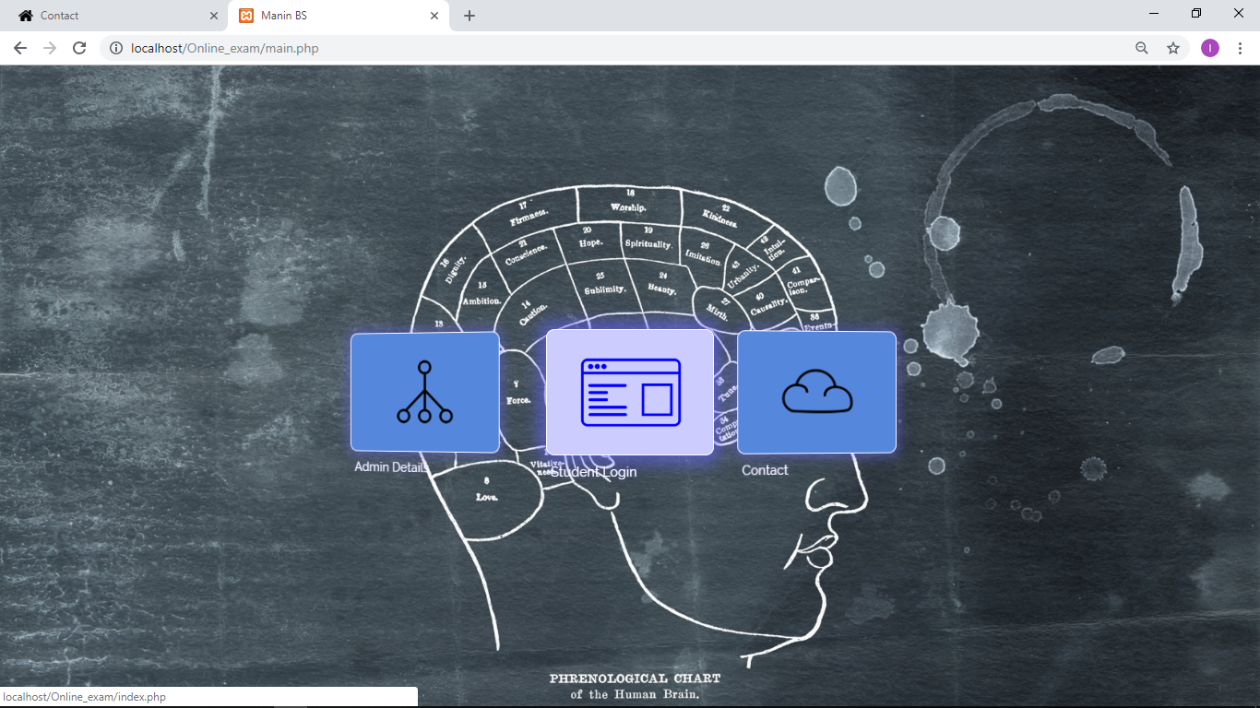

**About page:**

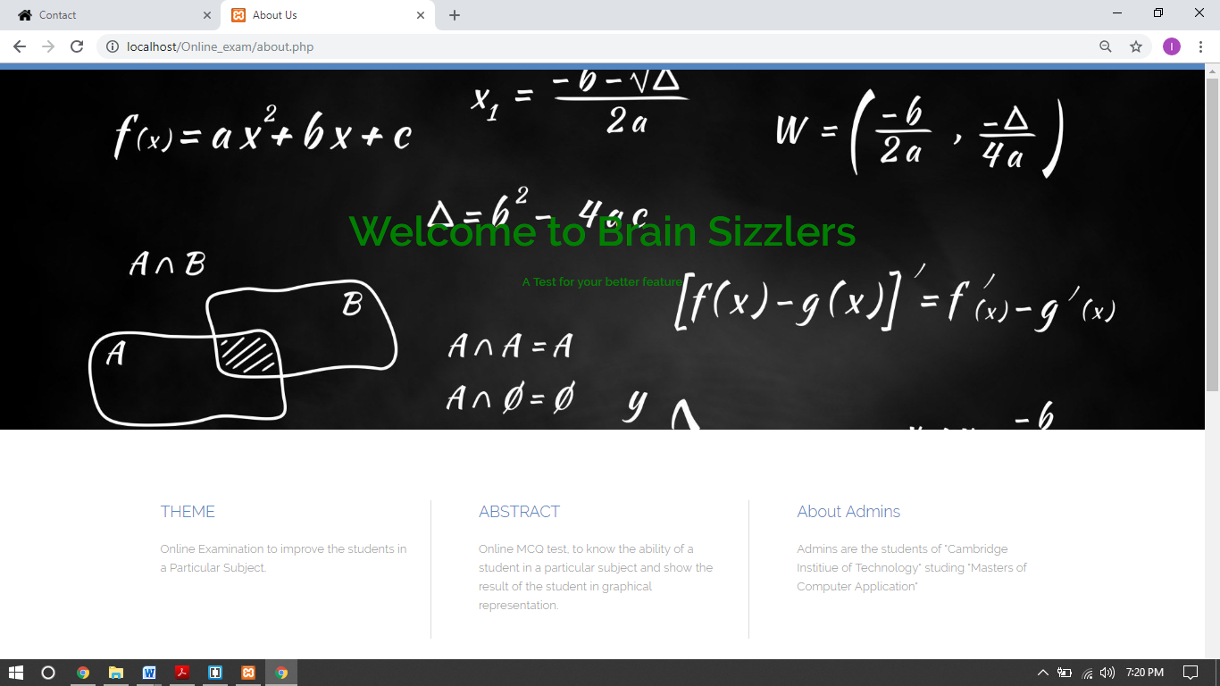

**Creators page:**

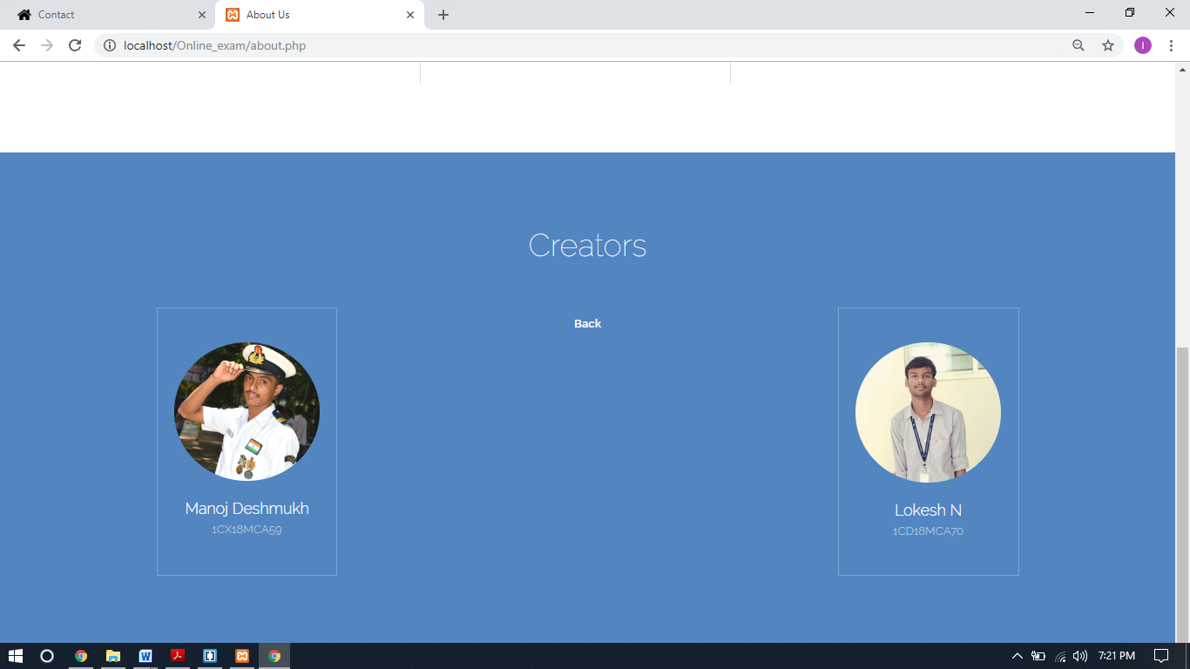

**Admin login page:**

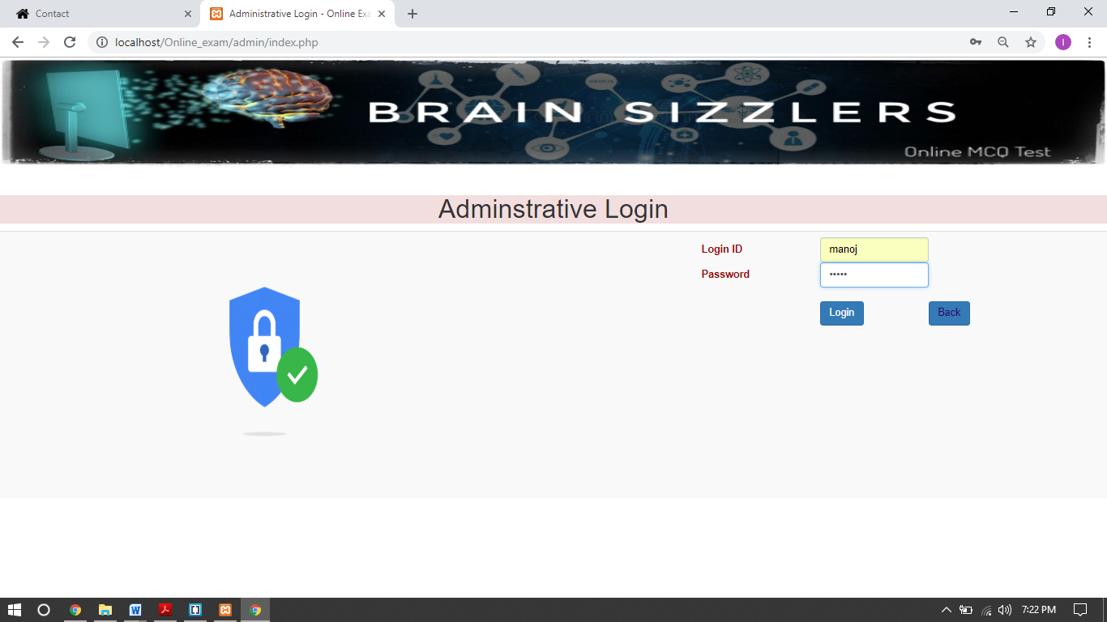

**Admin home page:**

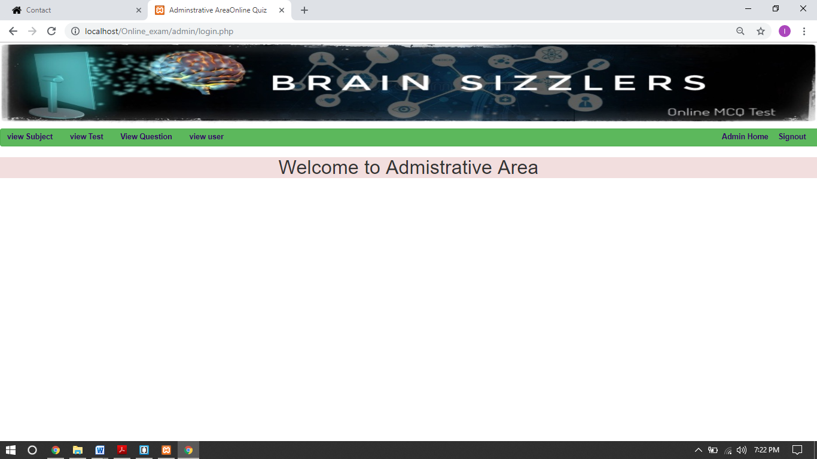

**Registered User Detail:**

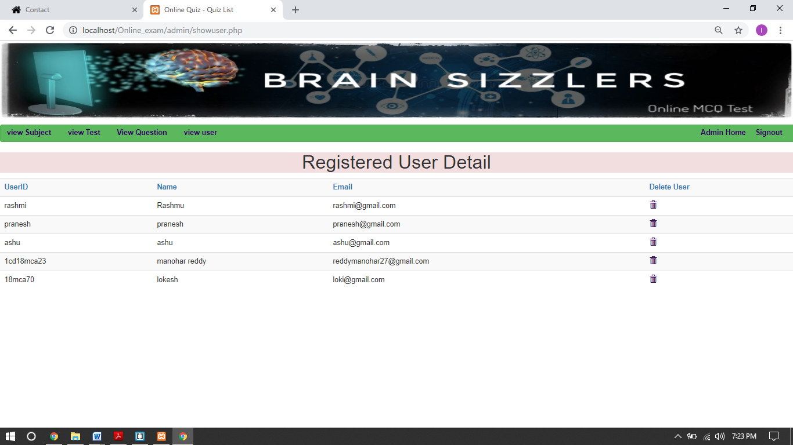

**User login page:**

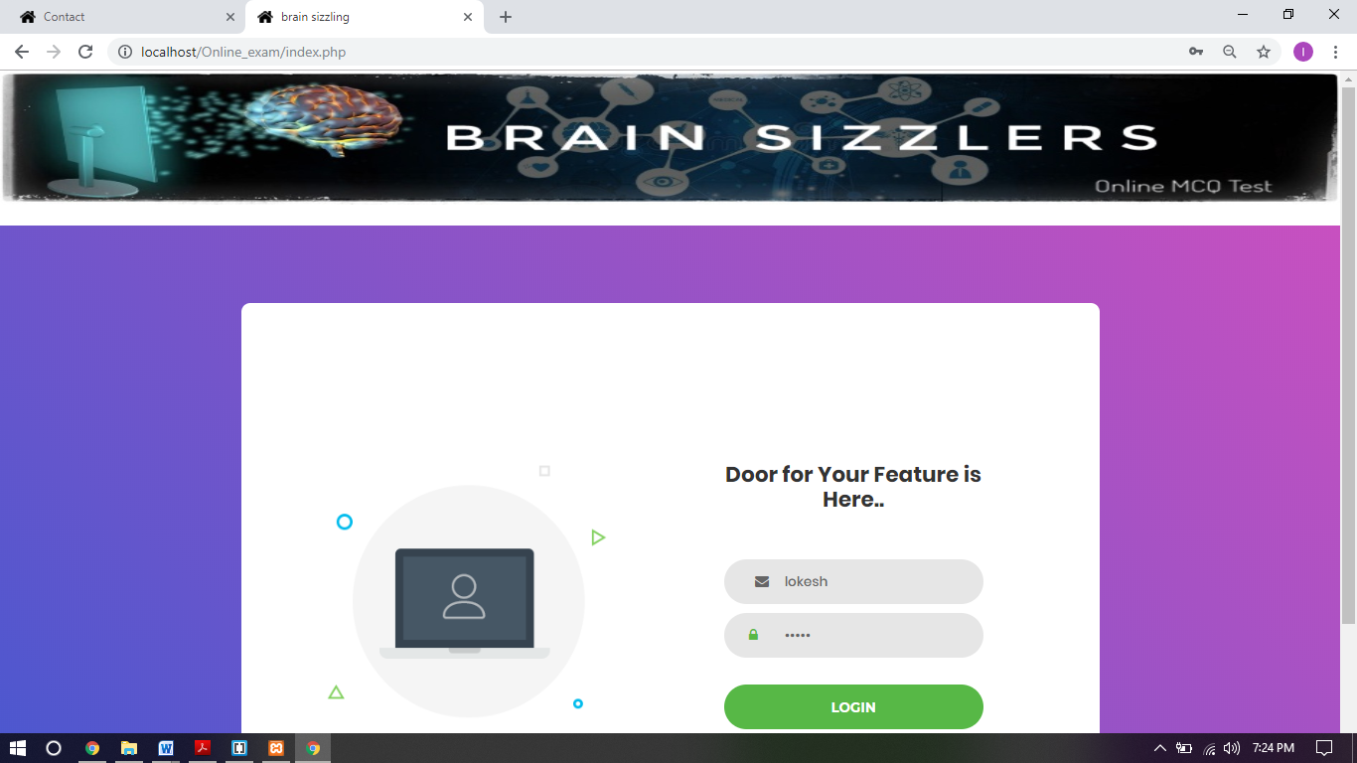

**Welcome page:**

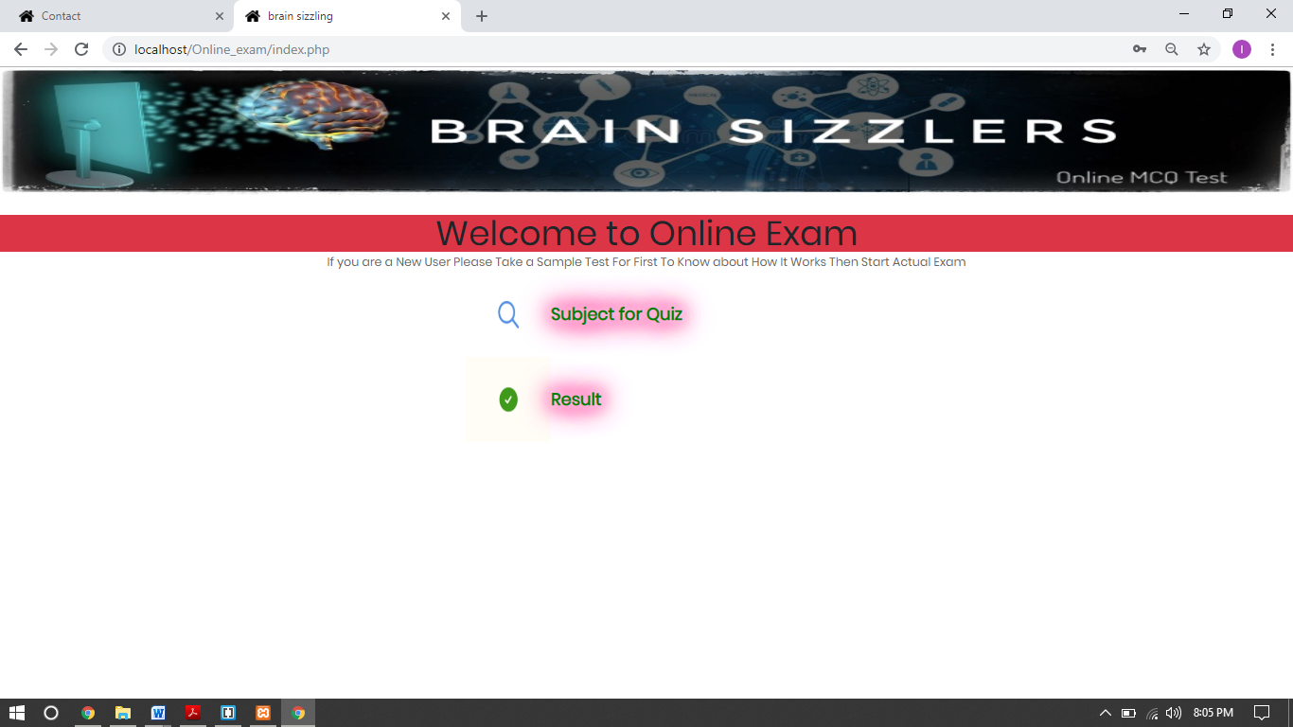

**Selecting test page:**

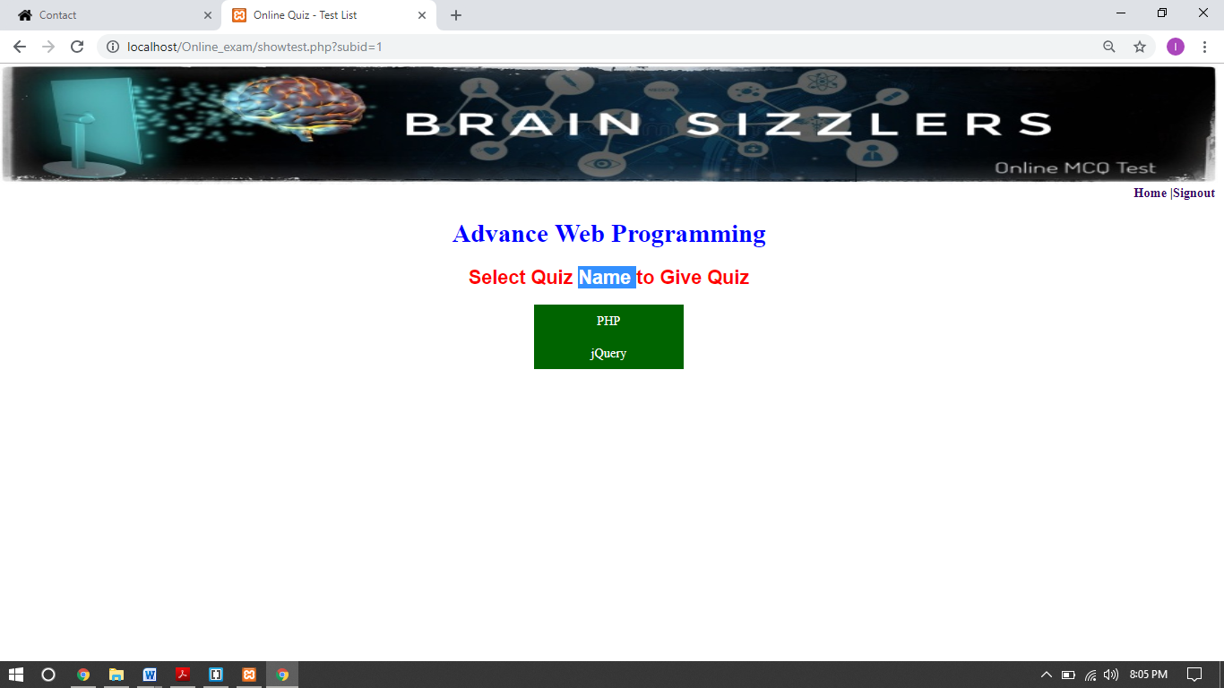

**Test starting page:**

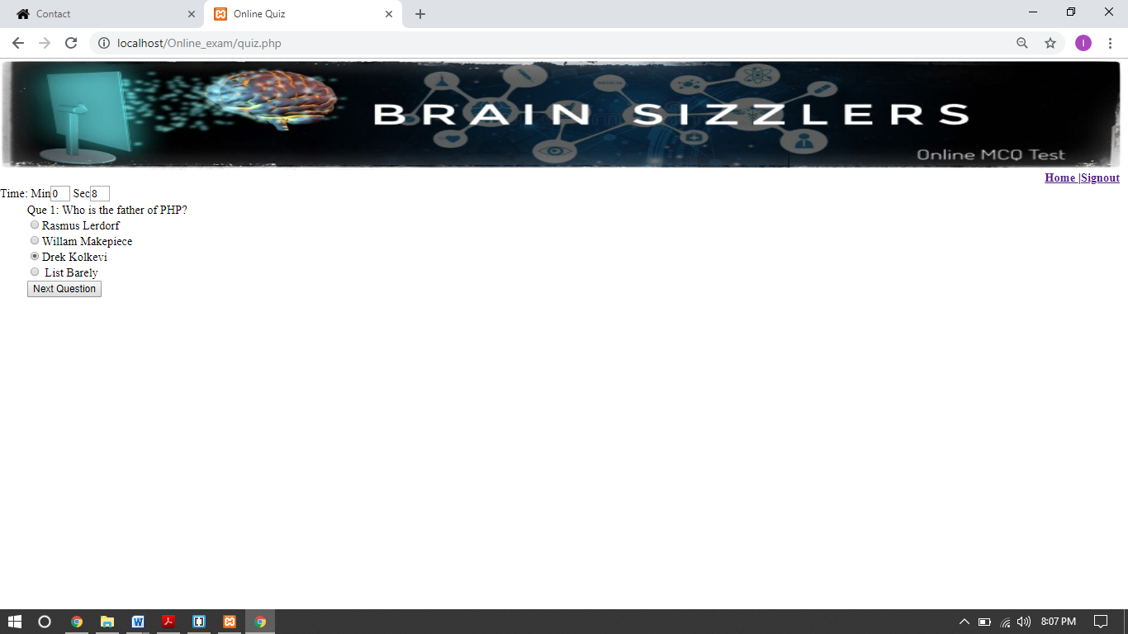

**Result page:**

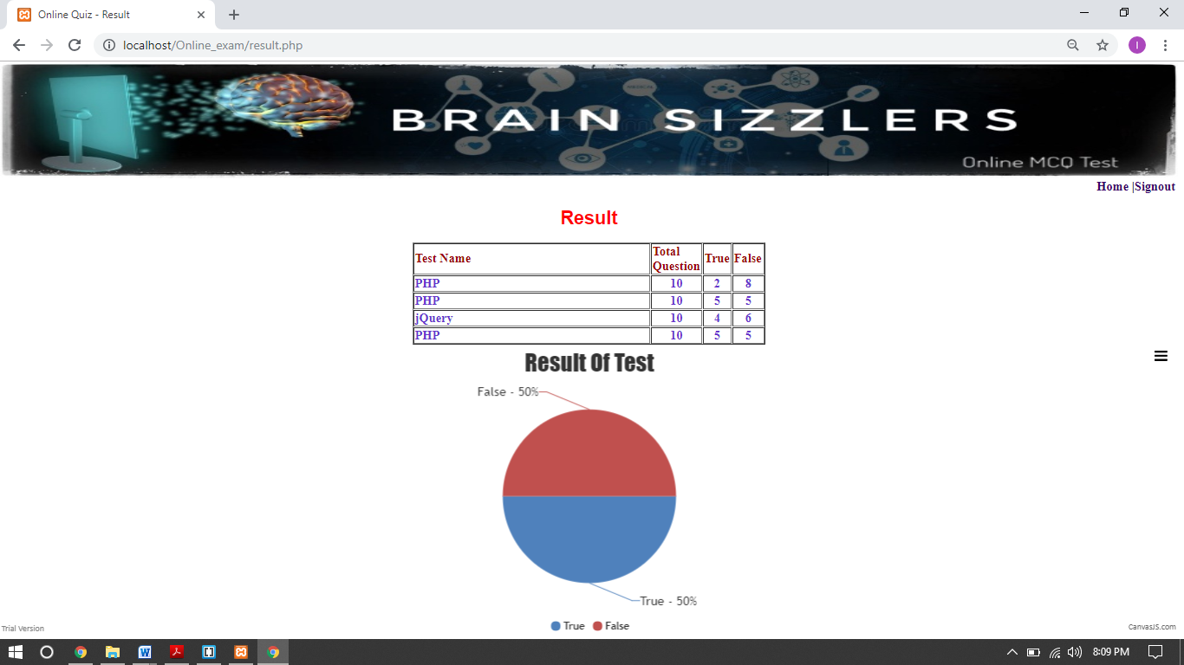

**Contact us:**

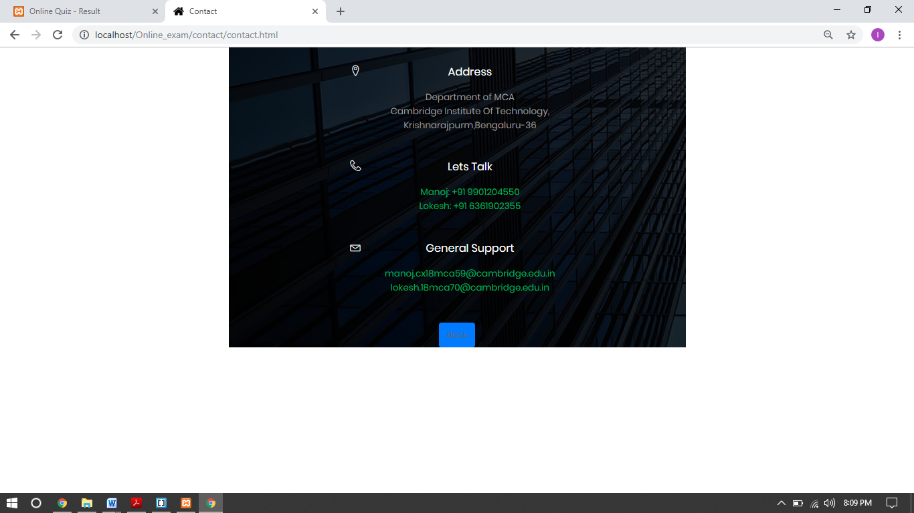

**6. Software Testing**

Software testing is a critical element of software quality assurance and representing the ultimate review to specification, design and coding.

**Test Cases:**

Test cases are built around specifications and requirements, i.e., what the application is supposed to do. Test cases are generally derived from external descriptions of the software, including specifications, requirements and design parameters. Although the tests used are primarily functional in nature, nonfunctional tests may also be used. The test designer selects both valid and invalid inputs and determines the correct output, often with the help of an oracle or a previous result that is known to be good, without any knowledge of the test object's internal structure.

**The advantages of this type of testing include:**

• The test is unbiased because the designer and the tester are independent of each other.

• The tester does not need knowledge of any specific programming languages.

• The test is done from the point of view of the user, not the designer.

• Test cases can be designed as soon as the specifications are complete.

**The disadvantages of this type of testing include:**

• The test can be redundant if the software designer has already run a test case.

• The test cases are difficult to design.

• Testing every possible input stream is unrealistic because it would take a inordinate amount of time; therefore, many program paths will go untested.

**Test cases:**

|  |  |  |  |
| --- | --- | --- | --- |
| **Test Cases** | **Test setup** | **Expected result** | **Actual result** |
| Login tab | Click the login button | Login page should open | Login page should open |
| Contact us tab | Click on the contact us tab | Contact page should open | Contact page should open |
| register button | Click on register button | The details should be validated and stored in database | The details should be validated and stored in database |
| Profile tab | Click on profile button | Profile page should open | Profile page should open |
| Forgot password button | Click on forgot password button | Forgot password page should open | Forgot password page should open |
| Logout tab | Click on logout button | User should come out from his/her account | User should come out from his/her account |

7. CONCLUSION

Exams don’t have to be a dreaded experience. By studying throughout the semester to prepare and develop your knowledge, and from this program, practicing and developing your test-taking skills, you can become more confident in test situations. This program was developed with the aim of giving you a better learning experience towards your best possible assessment outcome. You can also review the Better Essays program above, which was developed to provide you with steps to write a competent, well-structured essay.

It is always appreciated and it will be very useful if you now [**complete the brief evaluation**](http://studyskills.curtin.edu.au/better-tests/feedback-questionnaire/)which follows. Your views are highly valued, and will greatly assist us in making this a more effective program.

 The On line test System is developed using Java and sql fully meets the objectives of the system for which it has been developed. The system has reached a steady state where all bugs have been eliminated. The system is operated at a high level of efficiency and all the teachers and user associated with the system understands its advantage. The system solves the problem. It was intended to solves as requirement specification.

8. LIMITATION

* You have to keep in mind that your students will take the exam on their own device in their own time with nobody to check up on them, so you have to alter your questions to provide for this situation. You have to ask questions which are not easily to be retrieved from books or the internet. Or you can [add a timer](https://www.onlineexambuilder.com/features/online-test-maker-with-timer/item10236) to each question so there is no time to search for the answer.
* Open text questions are possible, but they don't auto-grade, so you have to check them yourself.
* An online exam system is a little bit more susceptible for [fraud](https://www.onlineexambuilder.com/knowledge-center/exam-knowledge-center/online-exam-cheating/item10616). So you have to keep that in mind if you setup your exam. Do you want to share the results immediately after the result? In that case you can setup a question bank to solve the issue of fraud. Handing out all questions & Answers of a question bank to students is ok. Because they have to learn all the questions & answers by heart. And when they're done they master the material. Read more about [proctored exams](https://www.onlineexambuilder.com/knowledge-center/exam-knowledge-center/proctored-exam-meaning/item12515).

**9. SCOPE FOR FUTURE ENHANCEMENT**

Scope of this project is very broad in terms of other manually taking exams.

Few of them are:-

 This can be used in educational institutions as well as in corporate world.

 Can be used anywhere any time as it is a web based application(user location doesn’t matter).

 No restriction that examiner has to be present when the candidate takes the test

**10. REFERENCES**

* + <http://www.w3schools.com>
  + <https://jquery.com/download/>
  + <http://www.truecodes.org>
  + <http://www.stackoverflow.com>
  + <https://canvasjs.com>
  + <https://www.edureka.co>
  + <https://www.daniweb.com>